**Key Indicator- 6.1 Institutional Vision and Leadership (15)**

|  |  |  |
| --- | --- | --- |
| **Metric No.** |  | **Weightage** |
| **6.1.1**  **QlM** | ***The governance and leadership is in accordance with vision and mission of the institution and it is visible in various institutional practices such as decentralization and participation in the institutional governance***  Write description in a maximum of 500 words  ***File Description:***   * Upload Additional information * Provide Link for Additional information | **15** |

1. Write 500 words about
2. Vision, mission, objectives of the college
3. Steps taken to improve governance
4. Interaction to improve the status of college by introducing various policies
5. Various learning opportunities provided to students and staff
6. Links to websites
7. Governing council minutes and various committees

**Key Indicator- 6.2 Strategy Development and Deployment (12)**

|  |  |  |
| --- | --- | --- |
| **Metric No.** |  | **Weightage** |
| **6.2.1**  **QlM** | ***The functioning of the institutional bodies is effective and efficient as visible from policies, administrative setup, appointment and service rules, procedures, deployment of institutional Strategic/ perspective/development plan etc***  Write description in a maximum of 500 words  ***File Description:***   |  |  | | --- | --- | | * Upload Additional information * Provide Link for Additional information |  | | **8** |

1. Write 500 words about institutional bodies

Attachments required

1. Service Rules
2. Promotion policies
3. Organizational charts
4. Appointment sample copy
5. Strategic plan 5 years (atleast last 3 plans)
6. Improvement in the strategy
7. Incentive policy

**Key Indicator- 6.2 Strategy Development and Deployment**

|  |  |  |
| --- | --- | --- |
|  |  |  |
| **6.2.2** | ***Implementation of e-governance in areas of operation*** | **4** |
| **QnM** | ***1. Administration*** |  |
|  | ***2. Finance and Accounts*** |  |
|  | ***3. Student Admission and Support*** |  |
|  | ***4. Examination*** |  |
|  | Options: |  |
|  | A. All of the above |  |
|  | B. Any 3 of the above |  |
|  | C. Any 2 of the above |  |
|  | D. Any 1 of the above |  |
|  | E. None of the above  **File Description (Upload)**   * Upload supporting document |  |

We have to include e-governance in

1. **Administration** (details of leaves, attendance must be included)
2. **Finance & accounts**(details salary must be included)
3. **Students admission support**; it must include following data:-
4. Grievances online
5. Student request for leave
6. Mentoring
7. Admissions
8. Student attendance

**Note**: Screen shot for the above must be attached

1. **Examination** ; it must include following data:-
2. Online application
3. Result
4. Admit card
5. Grievances

**6.3.1 Effective Welfare Measures**

|  |  |  |
| --- | --- | --- |
| **Metric**  **No.** |  | **Weightage** |
| **6.3.1**  **QlM** | ***The institution has effective welfare measures and Performance Appraisal System for teaching and non-teaching staff***  Write description in a maximum of 500 words  ***File Description:***   * Upload Additional information * Provide Link for Additional information | **6** |

* Effective welfare measures (write 500 words related to it)
* Leave policy details

1. Earned leave
2. Emergency leave
3. Fraternity leave
4. Casual leave
5. Vacation leave
6. On duty leave
7. Medical leave

* Faculty get together (details of date, venue etc)
* Festival gifts
* Teachers day gifts
* Best teacher/ Researcher award
* Free medical camp
* Salary advance
* Loan for vehicle/house purchase
* Local conveyance
* Snacks
* Incentives
* Gyanotsav (faculty sports meet)

**6.3.2 Teachers with financial support to attend conferences/workshops**

|  |  |  |
| --- | --- | --- |
| **.3.2**  **QnM** | ***Percentage of teachers provided with financial support to attend conferences/workshops and towards membership fee of professional bodies during the last five years***   * + - 1. Number of teachers provided with financial support to attend conferences/workshops and towards membership fee of professional bodies year wise during the last five years   𝑃𝑒𝑟𝑐𝑒𝑛𝑡𝑎𝑔𝑒 =  Total number of teachers provided with  financial support during the last five years × 100 Total number of full time teachers  year wise during the last five years  **File Description (Upload)**   * + - * + Institutional data in the prescribed format         + Upload supporting document | **12** |

**Fill as per format**

1. Letters of acceptance for conferences
2. Membership fees
3. Certification fees
4. Seed money

|  |  |  |
| --- | --- | --- |
| **6.3.3**  **QnM** | ***Percentage of teaching and non-teaching staff participating in Faculty development Programmes (FDP), professional development***  ***/administrative training programs during the last five years***  6.3.3.1. Total number of teaching and non-teaching staff participating | **15** |

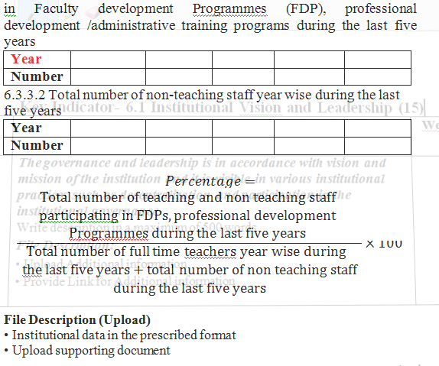

**Fill as per format**

Certification of FDP’S to be attended

|  |  |  |
| --- | --- | --- |
| **Metric No.** |  | **Weightage** |
| **6.4.1**  **QlM** | ***Institution has strategies for mobilization and optimal utilization of resources and funds from various sources (government/ non- government organizations) and it conducts financial audits regularly (internal and external)***  Write description in a maximum of 500 words  ***File Description:***   * Upload Additional information * Provide Link for Additional information | **10** |

Write 500 words

1. Financial audit certificates(external)
2. Financial audit certificates(internal)
3. Budget estimate of all departments
4. Sanction letters of budget

**Key Indicator- 6.5 Internal Quality Assurance System**

|  |  |  |
| --- | --- | --- |
| **Metric No.** |  | **Weightage** |
| **6.5.1**  **QlM** | ***Internal Quality Assurance Cell (IQAC) has contributed significantly for institutionalizing the quality assurance strategies and processes. It reviews teaching learning process, structures & methodologies of operations and learning outcomes at periodic intervals and records the incremental improvement in various activities***  Write description in a maximum of 500 words  ***File Description:***   * Upload Additional information * Provide Link for Additional information | **15** |

6.5.1 IQAC cell

Write 500 words

* IQAC policy
* IQAC meetings

1. Agenda
2. Attendees of meeting
3. Minutes of meeting

* Teachers Assessment and appraisals

|  |  |  |
| --- | --- | --- |
|  |  |  |
| **6.5.2**  **QnM** | ***Quality assurance initiatives of the institution include:***   1. ***Regular meeting of Internal Quality Assurance Cell (IQAC); Feedback collected, analysed and used for improvements*** 2. ***Collaborative quality initiatives with other institution(s)/ membership of international networks*** 3. ***Participation in NIRF*** 4. ***any other quality audit/accreditation recognized by state, national or international agencies such as NAAC, NBA etc***   **Options:**   1. All of the above 2. Any 3 of the above 3. Any 2 of the above 4. Any 1 of the above 5. None of the above   **File Description (Upload)**   * + Institutional data in the prescribed format   + Upload supporting document | **15** |

**6.5.2 Quality Assurance System**

1. Fill the date as per table

2. NIRF participation(PDF)

3. NBA certificates

4. IQAC feedback and analysis

5. MOU’S with national and international facilities